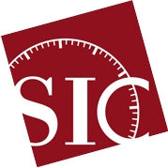
43rd Scientific Instrument Symposium
16 – 20 September 2024,
Ingenium, Ottawa, Canada
Precision Reconsidered: Scientific Instruments, Culture and Access

ABSTRACT SUBMISSION FORM
Session
Title of the session:
Organizer’s full name(s):
Affiliation(s):
Contact name and e-mail:
Abstract of the session (max 250 words)
Number of contributions:
For each contribution of the session:
Full name of the contributor(s):
Affiliation(s):
Title of the contribution:
Abstract of the contributor(s): (max 250 words):
Bionotes of the contributor(s): (max 50 words per author):

