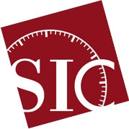
43rd Scientific Instrument Symposium
16 – 20 September 2024,
Ingenium, Ottawa, Canada
Precision Reconsidered: Scientific Instruments, Culture and Access

ABSTRACT SUBMISSION FORM
Poster
Author
Full name:
Affiliation:
Co-authors (if any)
Full name:
Affiliation:
Contact e-mail:
Title:
Abstract: (max 250 words)
Biographical notes of the author(s): (max 50 words per author)

